

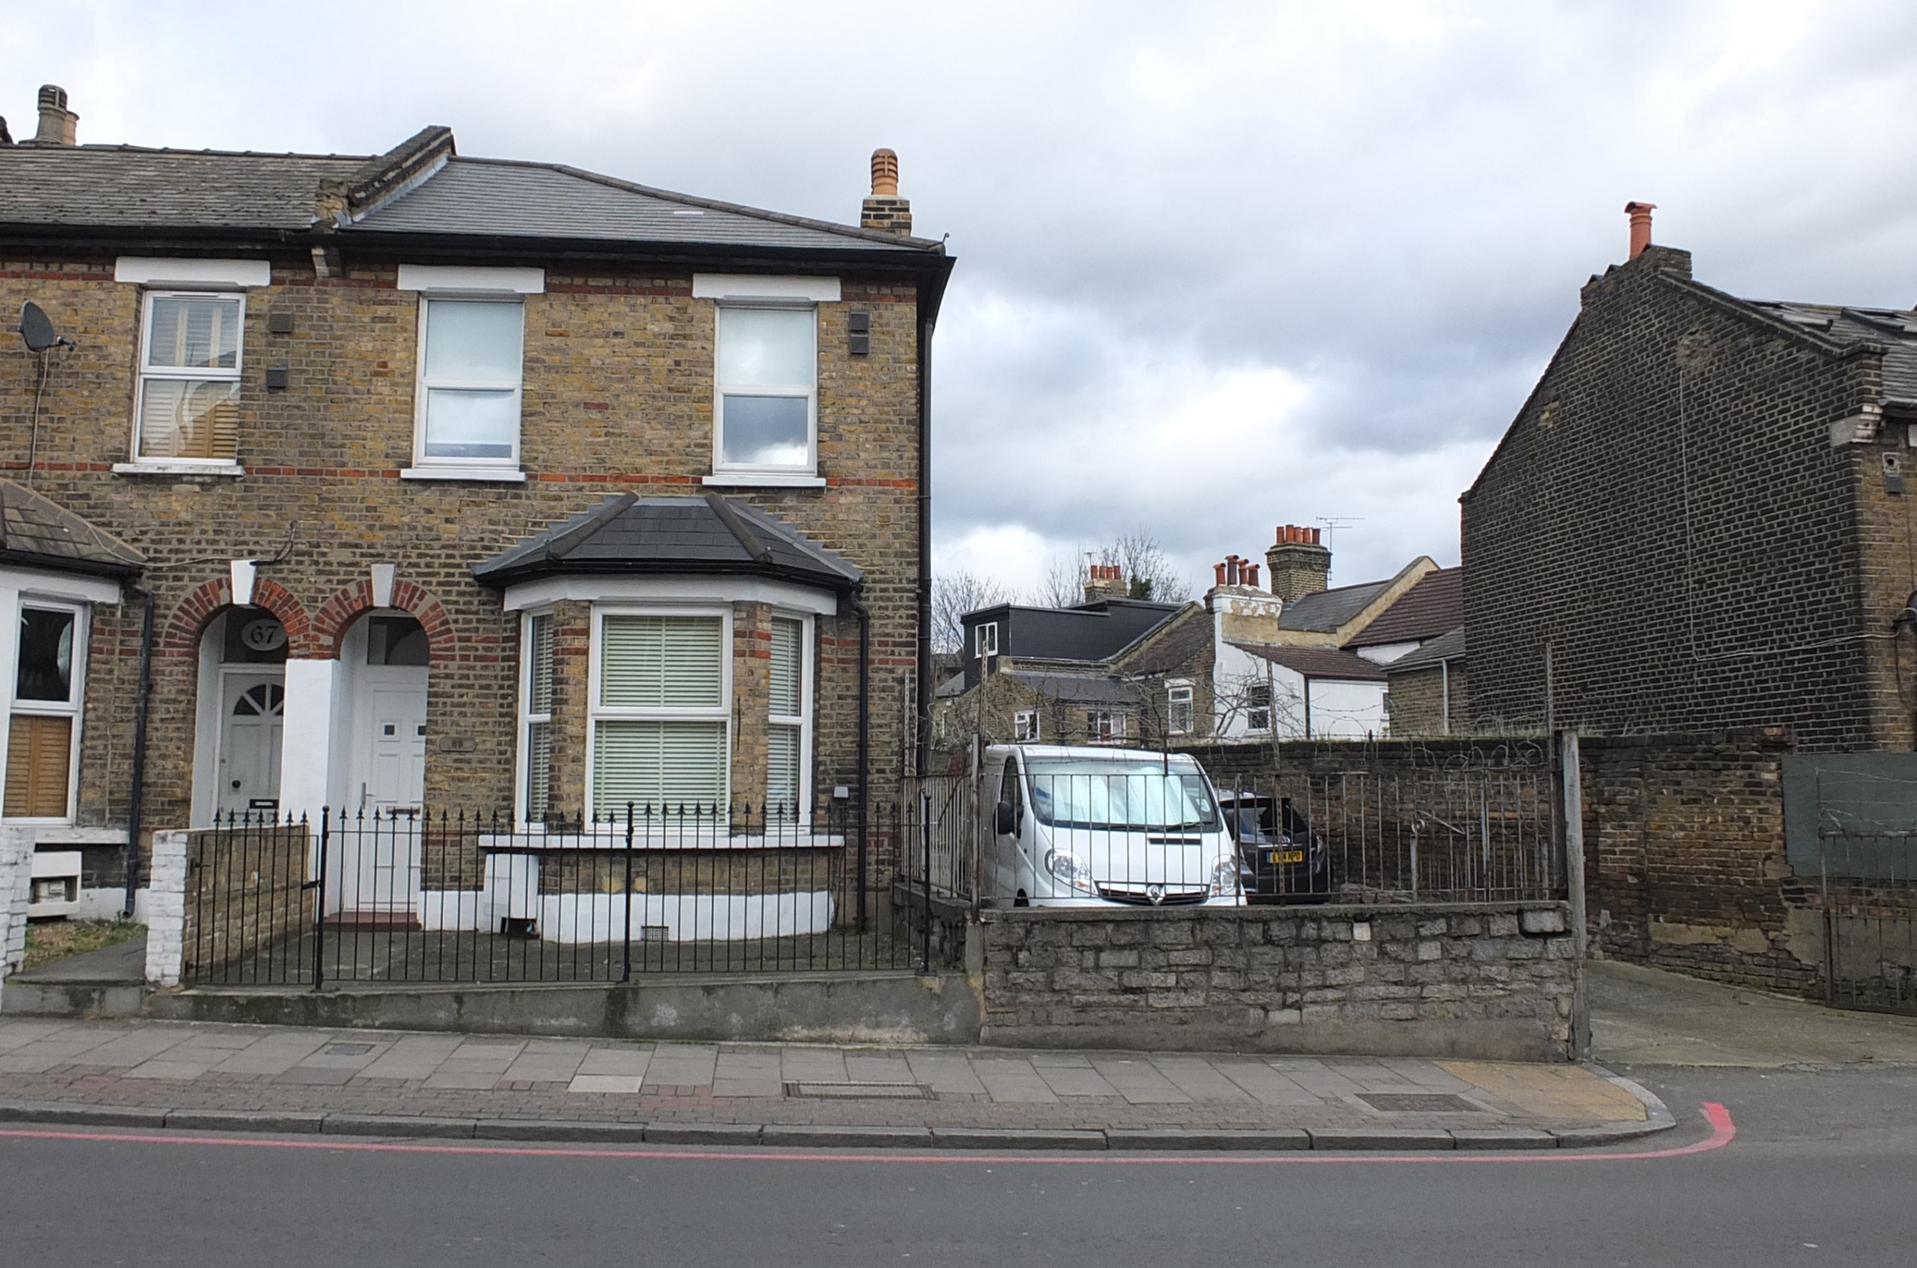

[www.londonandcity.com](http://www.londonandcity.com)

**London & City Residential - London**

T: 020 03 873 9139

E: [enquiries@londonandcity.com](mailto:enquiries@londonandcity.com)

O7970 571517

Situated in the Heart of Hackney, close to local shopping facilities and good transport links. A Fantastic opportunity to acquire a re-furbished Victorian House, fronting Kenworthy Road and rear site with garages and warehouse. Would be ideal for an end user looking to set up a business from home, or investor/developer. The site and House is to be sold on an un-conditional basis.

* Freehold
* Located in Hackney
* Refurbished Victorian House
* 3 bedrooms
* Potential Residential Development (STP)
* Rear Warehouse
* Mews environment
* Utility with 2 showers
* Large games room
* Parking for 2 cars
* Bespoke furnishings
* Coastal walks nearby
* Planning Permission To Extend

**69, Kenworthy Road, Hackney, London, E9 5RB**

£1,800,000 FREEHOLD



[www.londonandcity.com](http://www.londonandcity.com)

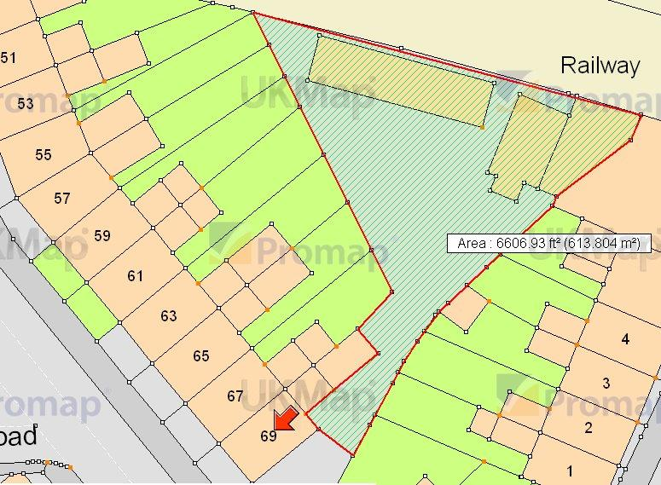

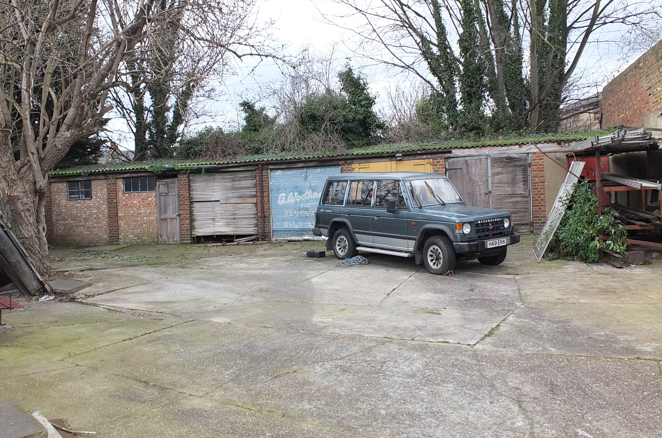



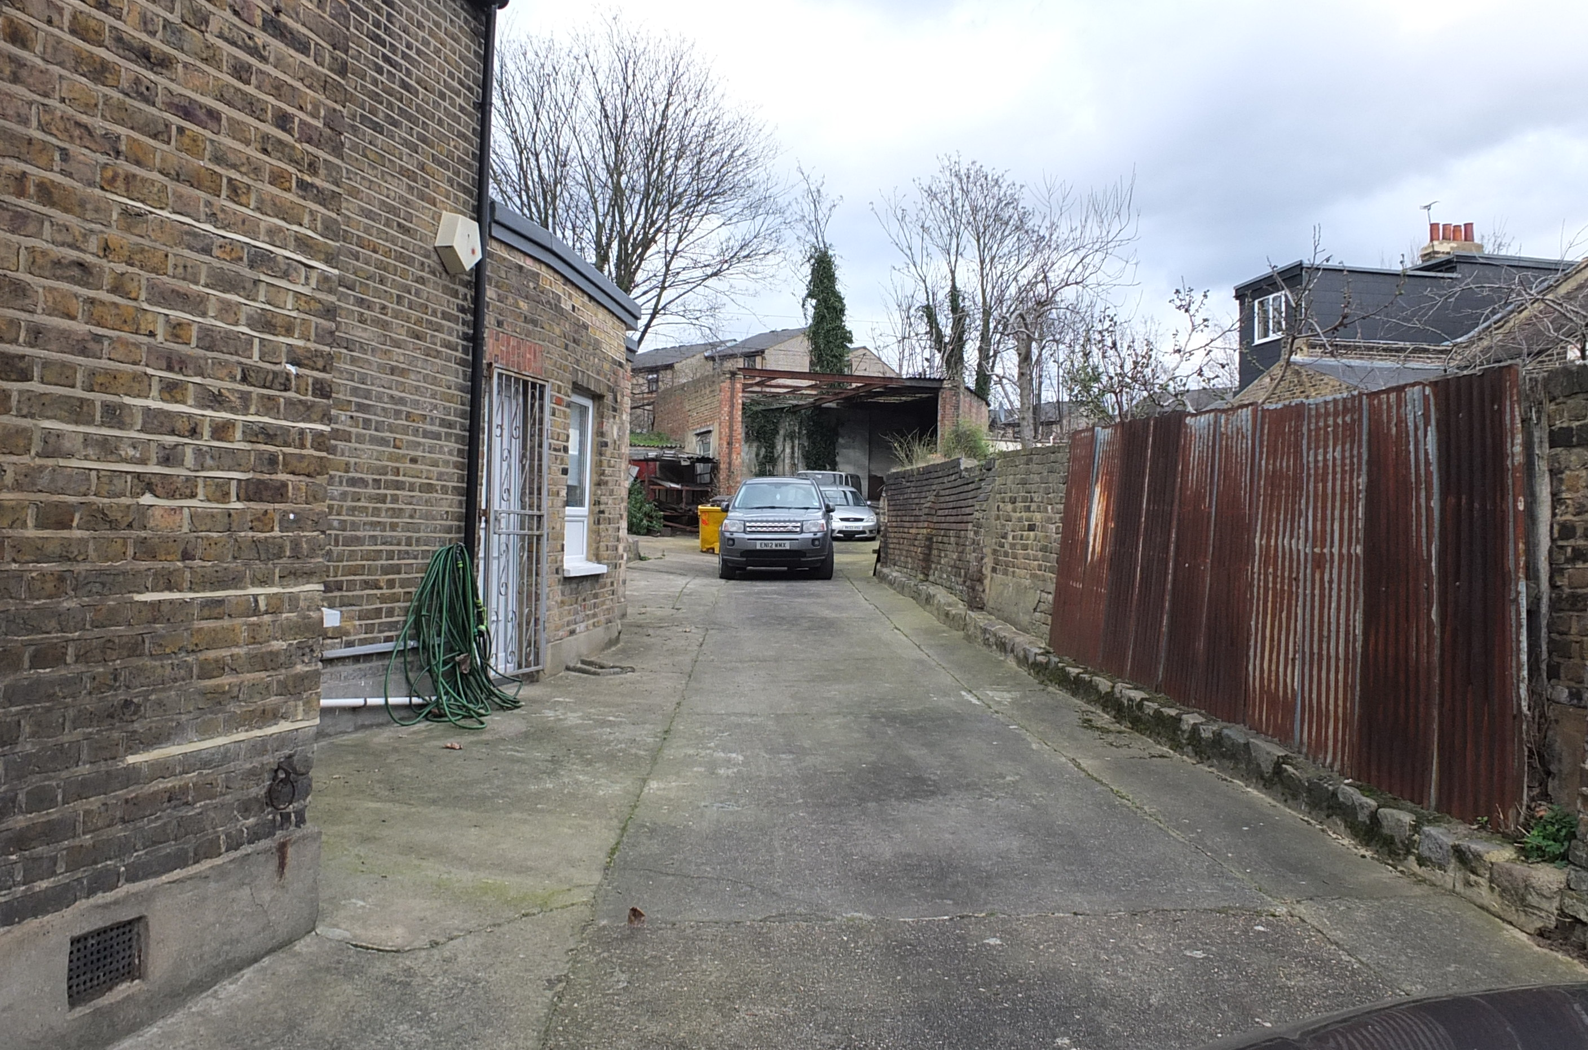

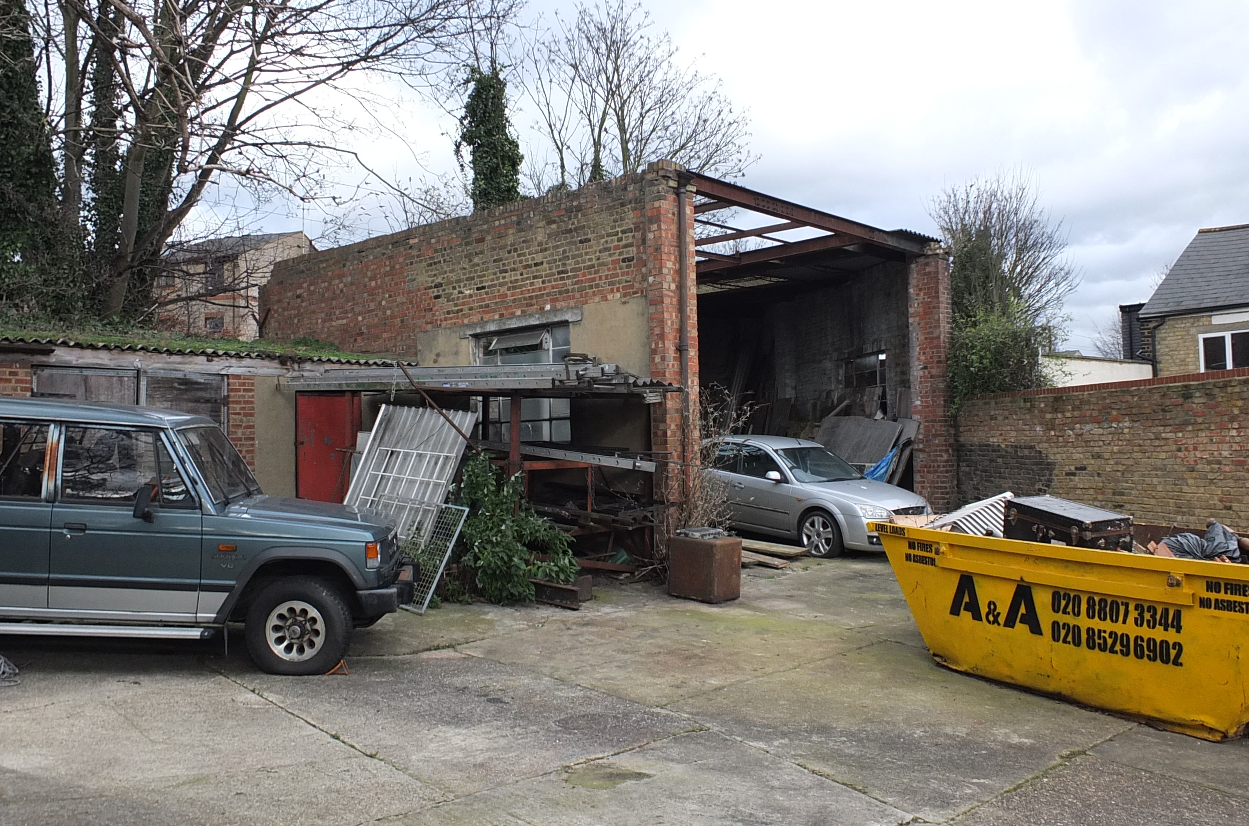

**Disclaimer**

Every attempt has been made to ensure accuracy, however these property particulars are approximate and for illustrative purposes only. They have been prepared in good faith and they are not intended to constitute part of an offer of contract. We have not carried out a structural survey and the services, appliances and specific fittings have not been tested. All photographs, measurements, floor plans and distances referred to are given as a guide only and should not be relied upon for the purchase of any fixture or fittings. Lease details, service charges and ground rent (where applicable) are given as a guide only and should be checked prior to agreeing a sale.

London & City Developments Ltd t/a London & City Residential Registered in England and Wales - 4043863

Registered Office: Third Floor 67-74 Saffron Hill, London, EC1N 8QX

.

■ Residential development opportunity in Hackney, E9

(subject to planning)

■ Site currently occupied by a 1960’s warehouse and garages with a refurbished Victorian House fronting Kenworthy Road.

■ Site to be sold on an un-conditional basis

■ Potential Mews Development

■ 6,606.93 ft (613.804sq m)

■ For sale freehold with vacant possession

For further information please contact:

Spencer young 07970 571517

[spencer@londonandcity.com](mailto:spencer@londonandcity.com)

Council Tax Band: C