

**£1,750,000 Freehold**

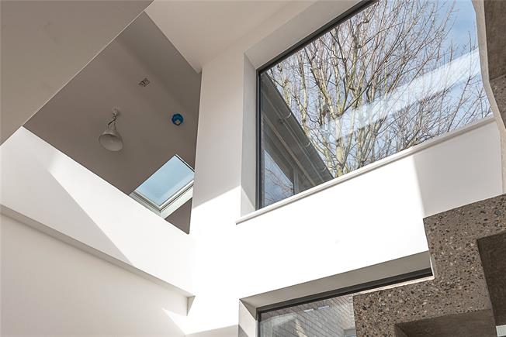

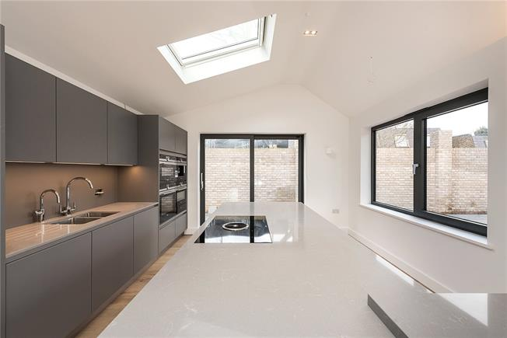

**www.londonandcity.com**

T: 020 3873 9139

lnewhomes@londonandcity.com

* Under- floor heating throughout
* Green sedum roof
* Shuco aluminium glazing
* Smart home system
* Siemens appliances

**St. Jame`s Lane, Musewell Hill, N10**

* 3 New Build Detached Houses
* 3/4 Bedrooms
* Open Plan Kitchens
* 3 Bathrooms
* Dining Area



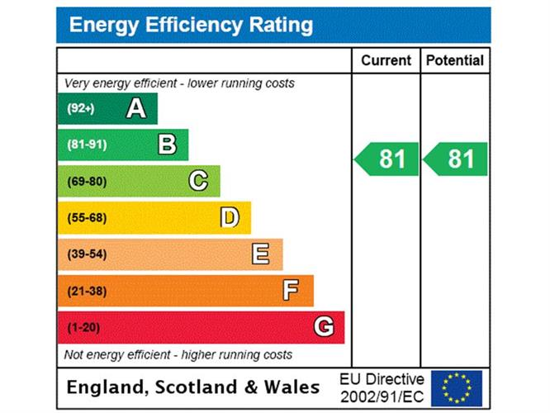

**Property**

London & City new homes have pleasure in offering a unique development of 3 contemporary detached newly built houses.

Offering contemporary living these fantastic houses have been built to a very high standard with high end fixtures and fittings. Stunning German kitchens, Siemans appliances with coffee machines, self cleaning ovens/combination steam ovens, microwaves.

Silestone worktops and centre island unit,intergrated induction hobs, bora extraction and instant boiling water.

Fabulous floor to ceiling windows, with sky lights, filling the houses with plenty of light.

Set over two levels, the lower levels offer three or four bedrooms with en- suites and dressing rooms. Upper levels offer reception area, fantastic Kitchen/ breakfast area with access to landscaped gardens, internal court yards, and has the benefit of private parking for each house.

Situated within walking distance to Muswell Hill Broadway, and all of the bars and restaurants of Muswell Hill Broadway. Bus routes provide direct links to the City and West End, as links to stations from Highgate, Hornsey and Finsbury Park.

Schools: Muswell Hill Primary, St Jame`s and Fortismere.

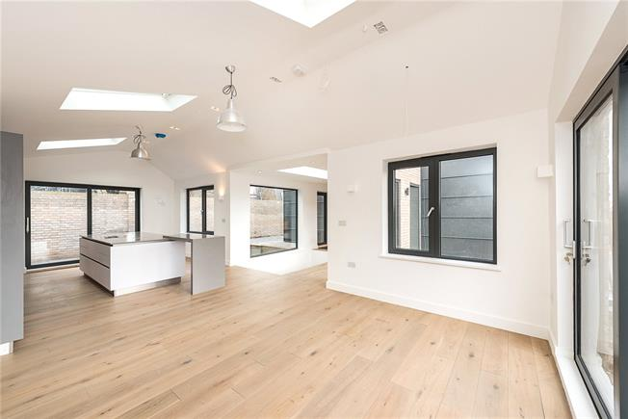

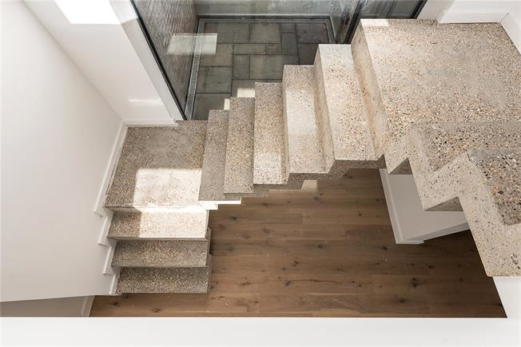

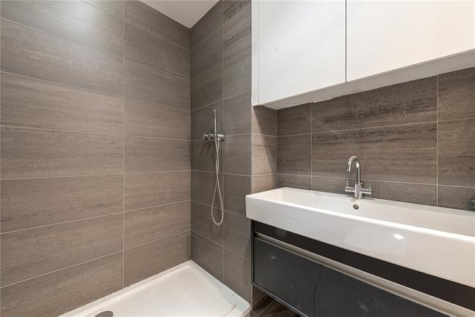

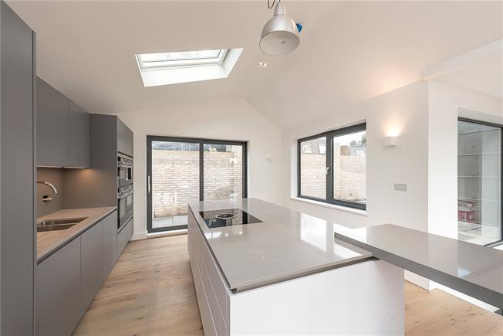

**Disclaimer**

Every attempt has been made to ensure accuracy, however these property particulars are approximate and for illustrative purposes only. They have been prepared in good faith and they are not intended to constitute part of an offer of contract. We have not carried out a structural survey and the services, appliances and specific fittings have not been tested. All photographs, measurements, floor plans and distances referred to are given as a guide only and should not be relied upon for the purchase of any fixture or fittings. Lease details, service charges and ground rent (where applicable) are given as a guide only and should be checked prior to agreeing a sale.

London and city. Registered in England and Wales -4043863

Registered Office: Klaco House, 28-30, St Johns Sqaure, London, EC1M 4DN

**London & City New Homes - London**

T: 020 3873 9139

E: newhomes@londonandcity.com

**www.londonandcity.com**

GUIDE ONLY

APPROX GROSS INTERNAL AREA

GROUND FLOOR: 1061 SQ.FT. (98.6SQ.M.)

LOWER FLOORS: 777 SQ.FT. (72.2 SQ.M)

TOTAL 1838 SQ. FT. (170.8 SQ.M.)



